***Invest on Insula Token and/or on Insula Token Liquidity Pool:***

***To access Insula Investment Products:***

* **Desktop:** copy paste the links below into your Google Chrome browser with MetaMask extension opened & follow the instructions.

* **Mobile:** copy paste the links below into your MetaMask App browser (1-Click top left-hand corner burger menu button 2-Click “browser”) & follow the instructions.

**Insula Token (ISLA):**

*Instructions:*

1. Copy paste this link into your browser:

<https://app.uniswap.org/#/swap?inputCurrency=0x697ef32b4a3f5a4c39de1cb7563f24ca7bfc5947>

**If ISLA does not show up, click "import token” and copy paste this address:**

0x697ef32b4a3f5a4c39de1cb7563f24ca7bfc5947

1. 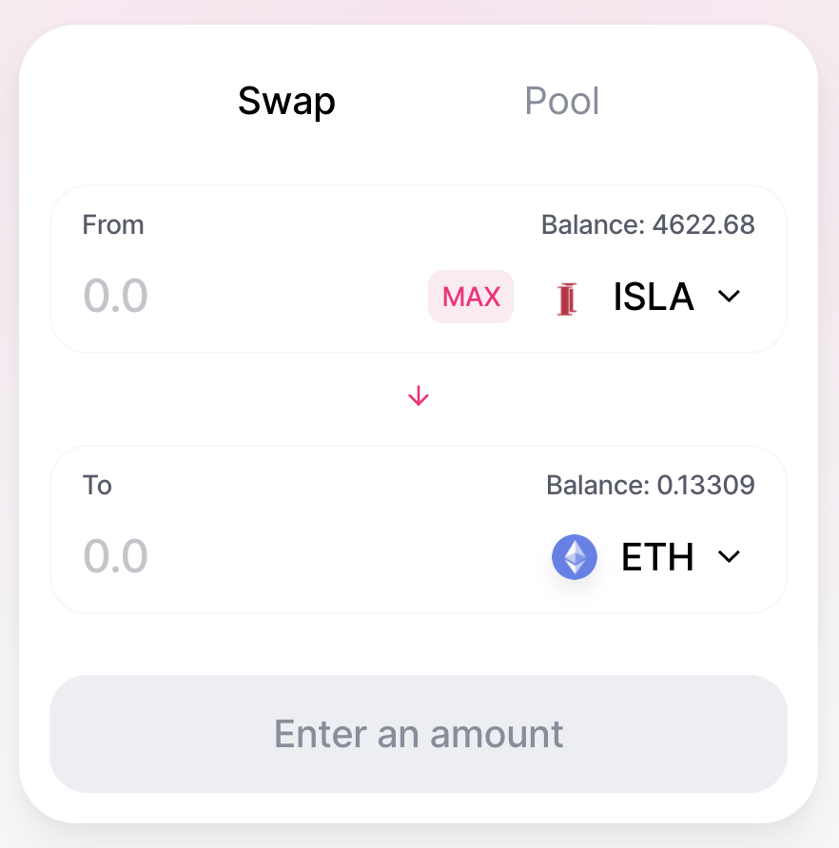When prompted*, import* “Uniswap default list”, *approve* ISLA & *swap* ISLA.

**Invest in the ISLA/ETH Pool:**

*Instructions:*

1. Copy paste this link into your browser:

<https://app.uniswap.org/#/swap?outputCurrency=0x697ef32b4a3f5a4c39de1cb7563f24ca7bfc5947>

**If ISLA does not show up, click "import token” and copy paste this address:**

0x697ef32b4a3f5a4c39de1cb7563f24ca7bfc5947

1. When prompted:

* **Import** “Uniswap default list”
* **Approve**ISLA
* **Swap** 40% of your ETH balance against ISLA.

1. Copy paste this link into your browser / or simply *click* “Pool”[:](https://app.uniswap.org/#/add/0x697ef32b4a3f5a4c39de1cb7563f24ca7bfc5947/ETH)

<https://app.uniswap.org/#/add/0x697ef32b4a3f5a4c39de1cb7563f24ca7bfc5947/ETH>

1. 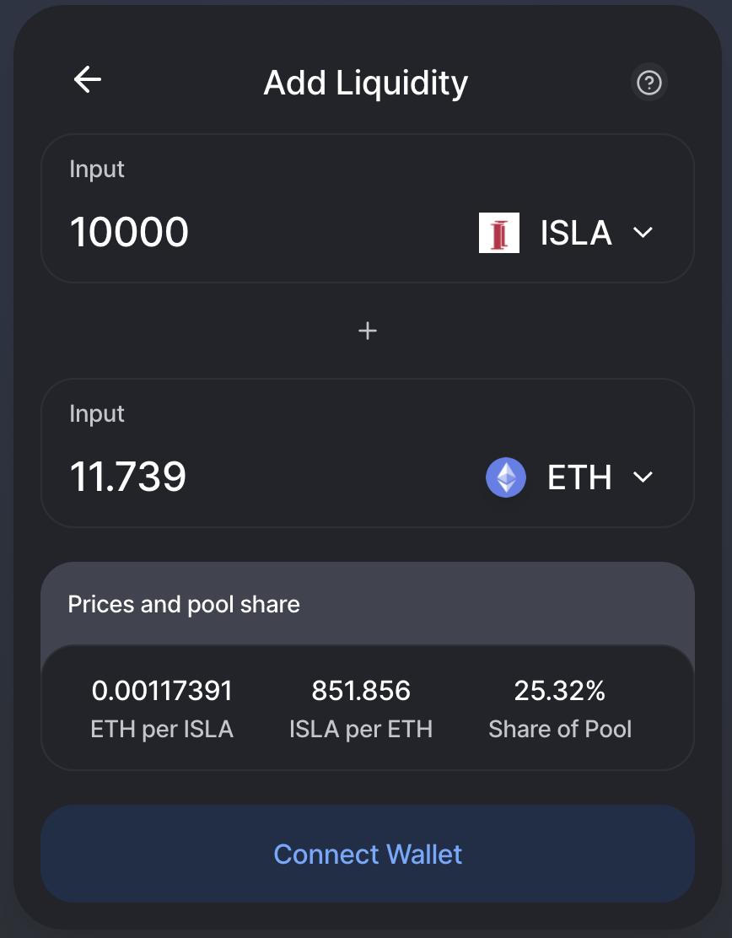Type the desired amount of ISLA & ETH to be added to the pool & click “*Add Liquidity*”.

**Further information:**

* [*Short guide*](https://insulainvestments.io/wp-content/uploads/2020/06/Placing-Insula-Tokens-in-the-pool.pdf)
* [*Detailed guide*](https://hackmd.io/MvvOYIKgQ8GD3VtNc2lmCA#How-to-join-Insula-in-5-very-simple-steps-5-mins)
* [*Underlying technology of Insula Pools*](https://hackmd.io/7OlueXatSSiE3l9f_RCrHg)